R Programming

NAME: K.Subashree REGNO:192521396

ARITHMETIC OPERATORS:
Used to perform basic mathematical operations such as addition, subtraction, multiplication, and division. They work directly on numerical values.
Addition (+) → Used to add values, such as combining marks from different subjects.
Subtraction (-) → Used to deduct values, for example reducing marks after penalties.
Multiplication (*) → Used to calculate totals, like multiplying average marks by the number of subjects.
Division (/) → Used to find ratios, such as computing average marks from total and subject count.
Exponentiation (^) → Used to raise a number to a power, for example squaring a student’s score.
Modulo (%%) → Used to find the remainder, such as checking leftover marks when grouped.
Integer Division (%/%) → Used to find the whole number quotient, like dividing total marks evenly among students.

EXAMPLES:
ADDITION
10+5
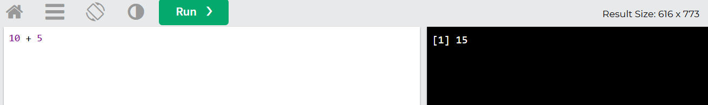
SUBTRACTION
10-5
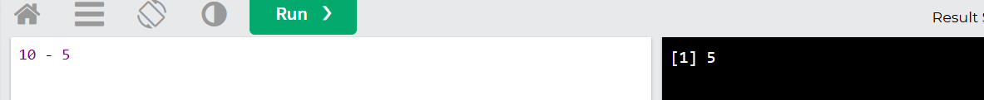
MULTIPLICATION
10*5

DIVISION
10/5

EXPONENT
2^5

MODULUS
INTEGER DIVISION
15%/%2
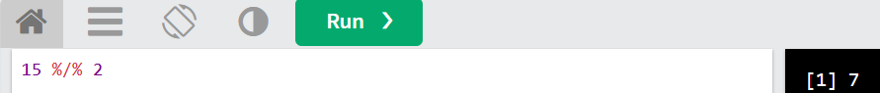
ASSIGNMENT OPERATORS:
Used to assign values to variables, often combining with arithmetic to update values efficiently. Examples include =, +=, -=, etc.
EXAMPLE
Student<-“Ravi”
Marks<-85
Marks<-marks+5
Student
Marks
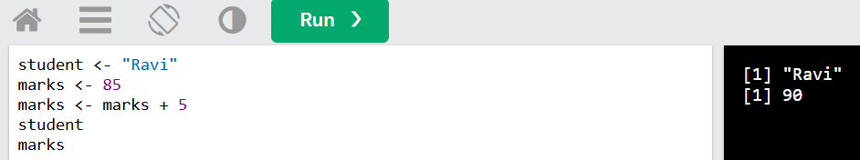

COMPARISON OPERATORS:
Used to compare two values and return a Boolean result (true or false). Examples include ==, !=, <, >, <=, >=.
EXAMPLE
Marks<-45
Pass<-Marks>=50
Pass
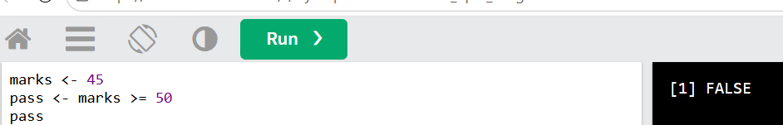
LOGICAL OPERATORS:
Used to combine or invert Boolean expressions, helping in decision-making. Common ones are && (AND), || (OR), and ! (NOT).
EXAMPLES:
AND (&& or &) → Returns TRUE only if both conditions are TRUE.
p <- TRUE
q <- FALSE
p && q
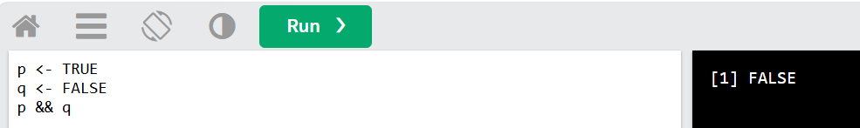
OR (|| or |) → Returns TRUE if at least one condition is TRUE.
marks <- 40
attendance <- 85
eligible <- (marks >= 50) || (attendance >= 75
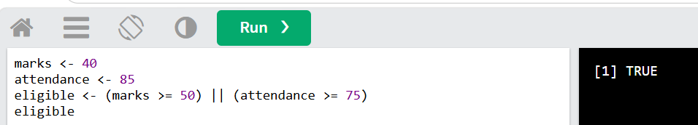
MISCELLANEOUS OPERATORS:
Special operators that don’t fit into other categories, such as sizeof, ?: (ternary), and pointer operators. They provide unique functionalities in programming.
EXAMPLE:
ope <- c(1, 2, 3, 4)
3 %in% ope
ope
